Revised Adult Education Block Grant
Annual Plan Template for 2015-16
Updated 10-7-2015

Section 1: Consortium Information

1.1 Consortium Grant Number:
13-328-18
1.2 Consortium Name:
Gavilan Regional Adult Career and Education Services

1.3 Primary Contact Name:
Mary Ann Sanidad

1.4 Primary Contact Email:
msanidad@gavilan.edu

If applicable:

1.5 Fiscal Agent Name:
1.6 Fiscal Agent Email:
wellis@gavilan.edu
Gavilan College

1.7 Identify each member organization currently within your Consortium, and your Consortium representative.
Table 1.7 – Consortium Membership (add rows as needed)
1.7a. Organization | 1.7b. Representative Name | 1.7c. Representative Phone | 1.7d. Representative Email | 1.7e. Date Officially Approved
Gavilan College | Randy Brown | 408.848.4847 | rbrown@gavilan.edu | September 8, 2015
Morgan Hill Unified School District | Dennis Browne | 408.201.6520 | browned@mhusd.org | August 4, 2015
San Benito High School District | Cindi Krokower | 831. 637-.840 x162 | ckrokower@sbhsd.k12.ca.us | September 15, 2015
Gilroy Unified School District | Deborah Padilla | 408.848.7167 | Deborah.padilla@gilroyunified.org | March 30, 2016
1.8 Use the Governance Template to describe how your Consortium operates programmatically
and fiscally.

Fiscal Operation: Gavilan College will act as fiscal agent for this block grant. All members have agreed to provide the consortium with budgets and expenditure reports for state, federal, local, and other funds used to provide services to adult students. Members will review budgets and expenditure reports at meetings of the governing board. Approval of the distribution schedule for Adult Education Block Grant funds will be by majority vote of the governing board.

Programmatic Operation: Meetings of the consortium will take place at regular times agreed upon by all members of the consortium. The project director will call meeting of the governing board, provide agendas in advance, and support staff will record minutes and provide them to all members in a timely manner. Members of the governing board will allow an opportunity for public comment on any agenda item prior to board action. Public notices of meetings and agendas will be posted on the consortium web site no later than seventy-two hours prior to every meeting. Each agenda item will include descriptions of proposed discussion topics. At each Governing Board meeting, time will be set aside for public comment. For members of the public not present, written submissions will be read aloud at the meeting. All public notices and public records are available to other entities within the region. Consortium staff will make special efforts to contact those that may be directly impacted by consortium decisions in order to ensure that they have opportunities to provide input for consideration in the governing board's decision-making process. Report outs from work groups carrying out follow up activities will be given to apprise colleagues of progress and to demonstrate participation in decisions made. As for decision-making, each member of the consortium will have one vote in deliberations of the governing board. Decisions of the governing board will require a quorum (3/5 member attendance), and approval by the majority of all members or their proxy. Participation in the meetings and voting can be in person or via telephone, video conference, or other electronic means of communication. Robert's rules of order will be followed. Consortium members gave their input to the development of the Rules and Procedures and agreed on this decision-making model.

Requests by agencies wishing to become members of the consortium will require approval by the governing board. On the other hand, a member who chooses to leave the consortium because it no longer wishes to provide adult education services consistent with the Regional Plan will submit evidence of approval of the decision to withdraw by the member's governing board. A member that cannot provide adult education services that address the needs identified in the Regional Plan, or that has been ineffective in providing adult education services after appropriate interventions have been unsuccessful may be dismissed from the consortium upon approval by the governing board. In the event of the pending dismissal of a consortium member, the governing board will communicate the reasons for this action to the member's governing board.

1.9 Attach an organizational chart to this plan submission. Show member relationships (including reporting) and interface with key partners, and identifying the fiscal agent (if applicable) and primary contact. See Guidance for sample and definitions.

1.10 Whether using a single fiscal agent or not, describe how you are fiscally managing your block grant. How are you rolling up grant expenditures to certify and report to the State? Who will be your Certifying Officer?

The certifying Officer will be Mr. Wade Ellis, Director of Business Services at Gavilan College. After distribution of funds to participating consortium members, the District will gather all information from each recipient and included/combined in the overall report.

Section 2: Plan Summary for Program Year 2015-16

The AEBG effort focuses on the purpose described in AB86: “… to rethink and redesign an educational system that creates seamless transitions for students across adult schools and community colleges to accelerate academic and career success in order to earn a living wage.” Your AB104 Adult Education Block Grant Three-Year Plan Update summarizes what your Consortium’s vision and goals are for your regional Adult Education system by the end of the three-year implementation period (by the end of program year 2017-18). The annual plans will focus on what will be done to make progress towards that vision.

2.1 Provide an Executive Summary regarding how your Consortium proposes to make progress in program year 2015-16 towards the realization the vision and goals of your Consortium’s AB104 AEBG Three-year Plan referred to above. What will your system look like by the end of 2015-16? See Guidance document for more information about this narrative.
The goal of this AEBG grant is to eliminate gaps in services, provide pathways for students that will accelerate them on their academic journey and prepare them for either post-secondary education or for the workforce. In year one of the block grant, Gavilan Regional Adult and Career Education Services (ACES)’ first goal is to lay the framework for the building of key services that have been missing for students in service areas such as counseling, learning disabilities testing, and childcare. While exceptional instruction is always a goal in education, if students don’t have the services they need to support them, they are likely to not achieve their short term and long term goals. Therefore, strides will be made in the first year to hire key personnel and have them begin provision of services to students.

In 2015-16, a tracking system will be identified and adopted so that student movement can be observed. This system will be especially important as common tools for assessment and placement are instituted, and cross referrals are made. Data will assess that the services offered function properly, and students are making progress toward their goals.

Cross-consortium, faculty-led work groups met throughout the planning year to learn about one another’s programs and to plan about how to redesign and/or augment the courses and programs currently being offered or to close the gap where some programs and courses do not exist. During the first year of implementation, instructors will continue this collaboration to design curriculum to be used in the areas of High School Diploma, High School Equivalency and Contextualized English as a Second Language and will identify and purchase complementary software, textbooks and other instructional tools.

Thus, year one will lay the foundation for future growth; the consortium will hire personnel, implement services and begin the process of curriculum creation and program expansion so that in the subsequent two years more classes and additional programs can be offered throughout the community.

Section 3: Consortium Services and Funding Allocations
3.1 Consortium Services by Program area, Member and Funding Source (Estimated). Please identify the types of services your Consortium will provide, and the funding that will go to support these efforts. Information about Levels of Service will be gathered in Section 6. Using the Member Allocations Workbook for Table 3.1, Consortium Members will fill out their own spreadsheets. The spreadsheets completed by individual Members will automatically be totaled together to provide the Consortium level figures on the Summary Sheet of the Workbook. Below is an overview of the information required.
Administration and MOE Indirect amounts are captured in Table 3.2b. The amounts entered in Table 3.1 should not include those expenses.
Table 3.1 Consortium Services by Program area, Member and Funding Source (Estimated)

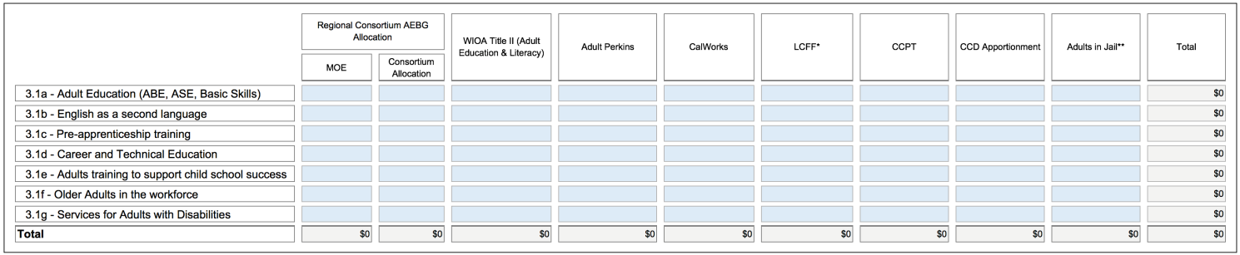
EXAMPLE

REVISED 3.2 Consortium AEBG Allocations by Member (Estimated).
NEW INSTRUCTION: Table 3.2 will capture total AEBG MOE and Consortium Allocations, and the amounts of those figures that will go Administration (5% cap) and the MOE Indirect amount that will be charged to the AEBG. Using the Member Allocations Workbook for Table 3.2, Consortium Members will fill out their own spreadsheets. The spreadsheets completed by individual Members will automatically be totaled together to provide the Consortium level figures on the Summary Sheet of the Workbook. Below is an overview of the information required.
Table 3.2 Consortium Allocations by Member (Estimated)
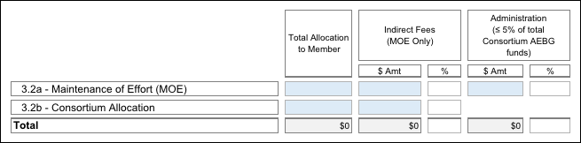
EXAMPLE
Section 4: Overview of 2015-16 Action Plans
Building off of your AB86 Final Plan, your AB104 Three-Year Consortia Plan Update and expected accomplishments for the 2015-16 program year, briefly outline your Consortium’s top 3-5 key activities for each of the Plan Objectives listed below for 2015-16. The original AB86 Objectives language has been adapted to the AB104 AEBG context.
4.1 Objective 3: Integrate existing programs and create seamless transitions into postsecondary education or the workforce. How will the Consortium align and connect existing and future adult education programs to postsecondary academic pathways and/or career pathways leading to employment? Activities should address how the Consortium will align placement tools, curriculum, assessment tools and rubrics, and student performance outcomes across delivery systems to ensure that student transition paths, both between providers and into postsecondary credit programs, are understood and supported across all systems.

Plans to facilitate transitions from adult education to college or career should include activities to support program alignment and pathways. Plans should also address support services needed to ensure that students have access to educational advising and that they develop educational plans to help them move toward their academic and career goals. Describe the specific activities the Consortium will employ to create the following:
● Educational pathways
● Alignment of:
○ Placement
○ Curriculum
○ Assessments
○ Progress indicators
○ Major outcomes - i.e., awards of high school diplomas, CTE certificates, etc.
● Transition strategies among the Consortium participants’ systems including:
○ Communication paths among Consortium participants and higher education institutions
○ Defined and articulated pathways to postsecondary education or the workforce
○ Embedded access to student services including counseling, guidance, and follow-up

4.1a Provide a description of your AEBG Regional Assessment Plan, i.e. how students will be appraised, placed, assessed, etc. into the regional adult system, as they progress, and as they move among the various schools. What tools and vendors will you be using for these activities?
With the exception of the Gavilan College credit ESL program, all consortium members use CASAS testing services. Use of the same test facilitates the assessment-placements process. When a student enters a program and takes the assessment, CASAS scores will be maintained in the TOPSpro Enterprise system, where they can be viewed by all consortium members. Developers at TOPSpro Enterprise are researching and developing a student identification process by which consortia will be able to track student movement within the region. Due to the work conducted during the planning phase of AB 86, the various programs’ levels and curriculum have nearly been completely articulated,, so when a student moves from one program to another, use of previous CASAS scores plus information about placement level and attainment in previous class will assist in determining placement in the subsequent program. Whereas others use CASAS, the College credit ESL program uses CELSA. Consortium plans include the final level in the adult schools and noncredit program to stop at the high intermediate level, where students will, upon successful completion, naturally enter the credit, possibly mirrored classes, thus creating a pipeline that feeds from literacy through college-level coursework . Again, since articulation and alignment are almost complete,- successful completion of other schools’ previous level will determine placement into the credit program.

4.1b Describe how you will track student enrollment, demographics, and performance. What system(s) will you be using? How will you collect the data from the student/classroom level? How will this system enable you to meet the targeted program outcomes?
Currently, the Consortium is talking with CASAS to use the TOPSpro Enterprise system, which will give ACES consortium-wide CASAS test results. They are also working on developing a student identification system to track movement regionally. At the College, the CCCapply and BANNER database systems record and monitor enrollment and demographic information. ARGOS is used to pull reports on transition from noncredit to credit courses. The College system can track numbers of students served and their transitions. ACES will be developing a system to integrate adult school student transitions.

In regard to data collection at the student/class level, many measures are taken: At the Adult School, outcomes are assessed in a variety of ways, depending on the course: In ESL, teachers measure student learning by observing student participation in class, by administering teacher-generated tests, and by implementing EL Civics Additional assessments. In High School Diploma classes, teachers grade student work, administer unit tests and final examinations, and evaluate student performance in project-based learning activities and demonstrations; In High School Equivalency Test Preparation classes, teachers measure student learning by observing student work on course materials and by administering and grading official HiSET practice tests. In all courses, students are pre and post-tested with CASAS after having completed 40-60 hours of instruction. In the College noncredit classes, term assessments measure Student Learning Outcomes (SLOs) and course progress, while in the credit classes, measures of different types (teacher and/or publisher-made quizzes and tests, oral presentations and compositions graded on rubrics, for example) are used throughout the semester and at semester end; SLOs are assessed regularly.

4.1c – Objective 3 continued: List other activities to integrate existing programs and create seamless transitions into postsecondary education and/or the workforce.

**For all subsequent tables, the following acronyms are used: MHUSD (Morgan Hill Unified School District), GUSD (Gilroy Unified School District), GC (Gavilan College) and SBHSD (San Benito High School District).
Table 4.1c – Objective 3: Other Key Integration and Seamless Transition Activities (add rows as needed)
4.1c(1). Activity | 4.1c(2). Timeline | 4.1c(3). Consortium Members Involved | 4.1c(4). Outcomes  Expected | 4.1c(5).Method of Assessing Impact
Adult ed/college math/English instructor work group- to determine need of range in instruction to prepare students for college work | Fall 2015-Spring 2016 | MHUSD, GC | Informed decision-making for ABE and HSD curriculum and workshops. | Successful completion of college-level math and English classes by Adult Ed graduates.
Counseling/  Assessment | Fall 2015-Spring 2016 | MHUSD, GC | Students who are better informed of their academic and workplace opportunities and have fully developed educational plans. Adult school students receive support in completing college applications and assessment exams. | Number of educational plans made and number of assessments administered by college staff at adult school sites.
Student Advisors | Spring 2016 | MHUSD, GUSD, GC | Students who are more knowledgeable about program classes and services | Number of students advised
Data Collection | Spring 2016 | MHUSD, GUSD, GA, SBHSD | A consortium that is aware of the strengths and deficits of its program in order to plan accordingly and make modification in services and delivery of services | Use of CASAS and TOPSpro Enterprise to pilot data collection
Project Director | Fall 2015-Spring 2016 | MHUSD, GUSD, GC, SBHSD | Facilitation of regular meetings; dissemination of State information; reporting of expenditures and activity progress to State | Timely decisions and successful submission of reports
Incentives | 2015-16-17 | MHUSD, GC | Incentives encourage the movement from classes in the community to the College and to complete programs | Number of students who transition to the College and who complete programs.
(PT) Enrollment Clerk | 2016-17 | GC | Extra help in processing noncredit application will allow students more rapid enrollment and subsequent attendance in classes. | Number of new students admitted and enrolled each semester

4.2 - Objective 4: Activities to address the gaps identified in Objective 1 (evaluation of current levels and types of adult education programs within its region, and Objective 2 (evaluation of current needs for adult education programs within the Consortium’s region), updated in your Updated AB104 3-year Plan. Describe how the Consortium will respond to the gaps identified in the region. These might include, but are not limited to, working with other partners in the service area, developing or expanding programs and plans to assess the effectiveness of these expanded efforts.

Plans will have identified programming and service gaps including lack of providers, services, access, attainment, and/or performance. Activities to address these should include strategies to incrementally increase capacity in identified gap areas (e.g., using distance learning to reach adult populations in a Consortium’s region who are currently underserved).

Table 4.2 - Objective 4: Key Activities for Addressing Gaps (add rows as needed)

4.2a. Activity | 4.2b. Timeline | 4.2c. Consortium Members Involved | 4.2d. Outcomes  Expected | 4.2e. Method of  Assessing Impact
Adult Basic Education (ABE) coursework | Fall 2015-Spring 2016 | MHUSD, GUSD, GC, SBHSD | Creation of curriculum for ABE classes, workshops, and boot camps and class offerings at adult schools | Instructor observation of student preparedness /test results for the HSE and HSD programs
High School Diploma Program (HSD) | Fall 2015-Spring 2016 | GUSD | Creation of HSD program for GUSD to be able to offer HSD in the three cities in our consortium | Number of students enrolled and earning credits in the GUSD
High School Diploma Program (HSD) | July 2015 – June 2016 | MHUSD, SBHSD | Classes for adults pursuing completion of the Adult High School Diploma; extension of school year to provide summer classes | MOE and AEBG expenditures; Credit completion, Level completions measured by CASAS and final exams, diplomas earned
English as a Second Language | July 2015 – June 2016 | MHUSD, GUSD, GC | 6 ESL classes at Beginning, Intermediate and Advanced levels at MHUSD and 4 ESL classes at Beginning, Intermediate and Advanced levels at GUSD; GC noncredit ESL offered at 17 off-campus sites; 4 levels of credit ESL offered at GC | MOE and AEBG expenditures; Level completions measured by CASAS tests and other assessments, advancement to higher levels
High School Equivalency Test Preparation | July 2015-June 2016 | MHUSD, GC | Classes for adults preparing for high school equivalency tests | MOE and AEBG expenditures; Level completions measured by CASAS; high school equivalency tests taken, High School Equivalency diplomas earned
Childcare | July 2015-2016 | MHUSD | Childcare services available to morning and/or evening students as  needed | Survey/Enrollment Increases

4.3 - Objective 5: Employ approaches proven to accelerate a student’s progress toward his or her academic or career goals, such as contextualized basic skills and career technical education, and other joint programming strategies between adult education and career technical education. Research has emerged in recent years identifying practices that reduce the time it takes for adult learners to progress through basic skills and career education pathways. Common strategies include compressing courses into shorter, more intensive terms (accelerated), individualized instruction based on a student’s competencies (competency-based), and putting basic skills content into the context of a student’s goals and career path (contextualized).
Many examples of these “best practices” are already in place within and among California adult education and community college programs. These “best practices” are not new to faculty; in fact, they have been developed by faculty. AB104 expects that the work done by regional consortia will include plans to make use of these strategies within their basic skills and career programs and in joint programming strategies.
In many places in the country, Integrated Basic Skills Training (IBEST) models, which contextualize the development of basic skills with the acquisition of workforce competency, have produced impressive data showing how learning can be accelerated while joining skills development with career readiness certifications. The AB104 website will continue to build links and resources tied to best practices and research done through adult education and community colleges.
Identify activities that you will implement and/or improve through using specific evidence-based strategies across the region, within and between systems where they currently don’t exist, to accelerate student’s progress.
Table 4.3 - Objective 5: Key Activities for Accelerating Student Progress (add rows as needed)
4.3a. Activity | 4.3b. Timeline | 4.3c. Consortium Members Involved | 4.3d. Outcomes  Expected | 4.3e. Method of  Assessing Impact
Contextualized ESL | Fall 2015-Spring 2016 | MHUSD, GUSD, GC | Creation of two levels of ESL in four CTE areas | Number of students who are able to go into the workforce with a certificate and job-ready/participate in an internship
Review ways to accelerate credit ESL program course sequence | Fall 2015-Fall 2016 | GC Credit ESL faculty | Fewer units, integrating academic courses and possible compression | Improved progression rates

4.4 - Objective 6: Collaborate in the provision of ongoing professional development opportunities for faculty and other staff to help them achieve greater program integration and improve student outcomes. A critical element to ensuring the effective implementation of the Consortium’s plans to improve adult education programs are faculty and staff equipped with the skills, knowledge, and support needed to deliver high-quality instruction and use classroom support strategies that foster learner persistence and goal achievement. Significant and effective professional development will be required to build capacity within the existing systems to deliver this new vision for adult learning throughout the state.

Faculty and staff from all local Consortium members and partners will need to implement collaborative professional development strategies to foster alignment and to support ongoing assessment and improvement of student outcomes.
Collaborative professional development plans should identify topic areas the Consortium considers a priority, such as:
● Practices in basic and secondary skills that build the “college readiness” skills.
● Team building, critical thinking, problem solving, study skills, soft skills, and career assessment.
● Technology use and integration to enhance and expand technology in Instruction.
● New models and instructional strategies for contextualized and/or accelerated teaching and learning.
● Skills building intercultural competence among faculty, staff, and administrators.

Examples of collaborative activities might include developing professional learning communities comprising faculty in the same content area, representing all Consortium participants. Plans might also describe joint team participation in professional development activities offered through regional/statewide associations and how these teams might share what they learn with other faculty. Consortia may also want to consider having field experts come to a regional facility to provide in-house training to greater numbers of staff, faculty and administrators. Consortia in areas where transportation may pose a problem may want to develop plans to use technology to overcome that challenge.

List activities that your consortium will implement to collaborate in the provision of ongoing professional development opportunities for faculty and other staff to help them achieve greater program integration and improve student outcomes.

Table 4.4 - Objective 6: Key Activities for Professional Development Collaboration (add rows as needed)
4.4a. Activity | 4.4b. Timeline | 4.4c. Consortium Members Involved | 4.4d. Outcomes  Expected | 4.4e. Method of  Assessing Impact
Pre- Semester Spring Meeting | January 2016 | MHUSD, GUSD, GC, SBHSD | Reiterate purpose of the consortium, review gains of small work groups, present 2015-16 plans | Observation of continued positive work dynamic
2-3 day symposium | Spring 2016 | MHUSD, GUSD, GC, SBHSD | Further bonding, heightened knowledge of best practices | Use of workshop methods in classroom instruction

4.5 - Objective 7: Leverage existing regional structures, including, but not limited to, with local workforce investment areas. Describe how the Consortium will leverage existing assets or structures to benefit the adult learners in the region. These assets or structures might include, for example, contributions from or collaborations with local Workforce Investment Boards (WIBs), industry employer groups, chambers of commerce, and county libraries.

For example, a Consortium might include in its plan to offer classes, taught by one of the member districts, at a local Workforce Development Center which is easily accessible by members of the community. Another Consortium might opt to work with the industries in its region to develop a career transition program focused on helping students with disabilities gain the necessary skills to enter the workforce.

Partners might include but are not limited to:
○ WIBs
○ Chamber of Commerce
○ County Libraries
○ County Office of Education
○ Industry Employer Groups
○ Literacy Coalitions
○ Economic Development Regions
○ County Social Services - CalWorks
○ Employment Development Department (EDD)
Examples of activities include:
○ Outreach by the regional Consortium to existing regional structures not yet involved Adult Education that could address a gap or need
○ Expanding utilization of existing regional resources for Adult Education students
○ Participation of Consortium Members in organizations that involve employers, Economic and Workforce Development to enhance responsiveness to economic needs

List activities to leverage existing regional structures and utilization of resources.

Table 4.5 - Objective 7: Key Activities for Leveraging Structures and Assets (add rows as needed)
4.5a. Activity | 4.5b. Partner(s) | 4.5c. Contribution(s)  Made | 4.5d. Consortium  Members Involved | 4.5e. Timeline | 4.5f. Customers  Expected | 4.5g. Method of  Assessing Impact
Literacy and Computer Literacy keyboarding classes | Vision Literacy, Gilroy | Class offerings in downtown Gilroy and MH; Create Processing Center in downtown to do intake, assess and place students in consortium programs | MHUSD, GC | Fall 2015-Spring 2016 | Students with low language levels | Student movement from literacy to beginning levels of ESL and general growth to consortium enrollments
Business/  entrepreneurship workshops | El Pajaro Community Development Corporation, Watsonville | Advise curriculum development in the Business ESL class and to provide more intensive follow-up business incubation services | MHUSD,GUSD, GC | Fall 2015-Fall 2015 | Students with an interest in studying or going into business | Number of students successfully completing vocational certificates
 | First 5 | Facility Use | GC | Fall 2015-Spring 2016 | Additional students | Number of students attending
 | County Library System | Facility Use | GC | Fall 2015-Spring 2016 | Additional students | Number of students attending

Section 5: Estimated Allocations by Objective

5.1 Allocation by Objective, Member and Funding Source (Estimated). Provide an estimate of the budget the Consortium will plan to expend in order to carry out the activities (including those not listed above) relevant to each Objective. It is understood that these figures will change over the course of implementation, so this would be your best estimate at this time. Using the Member Allocations Workbook for Table 5.1, Consortium Members will fill out their own spreadsheets. The spreadsheets completed by individual Members will automatically be totaled together to provide the Consortium level figures on the Summary Sheet of the Workbook. Below is an overview of the information required.
Administration and MOE Indirect amounts are captured in Table 3.2b. The amounts entered in Table 5.1 should not include those expenses.
Table 5.1 - Allocation by Objective, Member and Funding Source (Estimated)

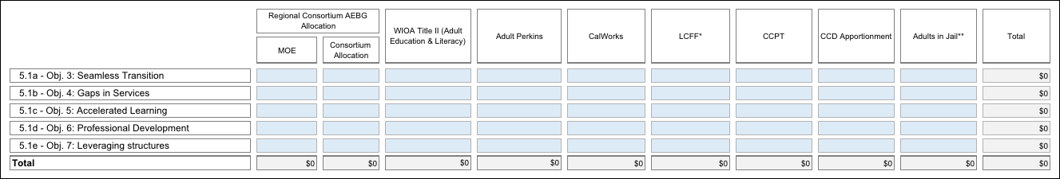
EXAMPLE

Section 6: Levels of Service and Assessment of Effectiveness
6.1 Projected Levels of Service. Provide a the number of students served in 2013-14 as identified in your AB86 Final Plan, as applicable, and target numbers for each of the AB104 AEBG Program Areas listed in the table shown below. Estimates for the figures for the new AB104 AEBG program areas (Pre-Apprenticeship training, Adults training to support child school success, and Adults in the Workforce, Including Older Adults) are acceptable. Duplicated headcounts are acceptable as some students may be in more than one program. You may add notes to explain your baseline and target figures, if necessary. It is understood that these figures will change over the course of implementation, so this would be your best estimate at this time.
Using the Performance Measures Workbook for Table 6.1, Consortium Members will fill out their own spreadsheets. The spreadsheets completed by individual Members will automatically be totaled together to provide the Consortium level figures on the Summary Page of the Workbook. Below is an overview of the information required.
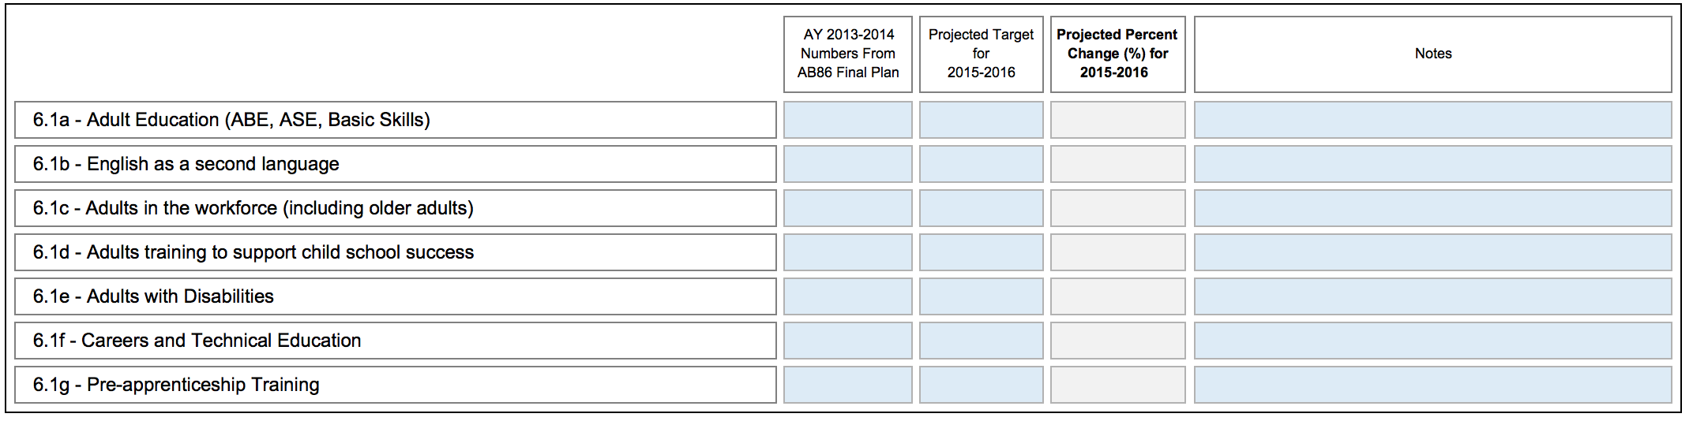
EXAMPLE
Table 6.1 Levels of Service by Program Area and Member (Projected Targets)

6.2 Project Performance Outcome Targets. Provide target percentages for each of the performance measures listed in the table shown below. See the Guidance document for more information on this section, and resource links for goal-setting approaches.

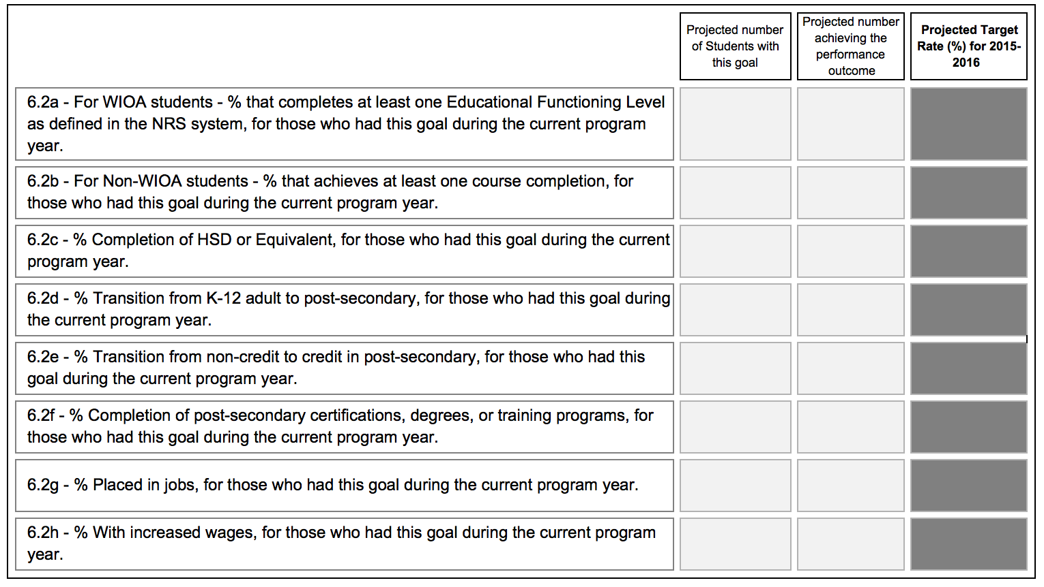
Using the Performance Measures Workbook for Table 6.2, Consortium Members will fill out their own spreadsheets. The spreadsheets completed by individual Members will automatically be totaled together to provide the Consortium level figures on the Summary Page of the Workbook. Below is an overview of the information required.
Table 6.2: Performance Outcomes by Member – Projected Targets
If you have unique, extenuating circumstances that you wish to describe regarding any of these measures, please name the measure by number and briefly describe the issue.

[Page allowance: 1/2 page. Enter or Paste Here]

6.3 List and describe any additional measures your Consortium will be tracking in order to gauge the impact of the Consortium’s plan efforts. (Optional – see Guidance document for information)

[Page allowance: 1/2 page. Enter or Paste Here]
6.4 List and describe the approaches or measures you as a Consortium will be looking at to evaluate the effectiveness of your Consortium. (Required)

[Page allowance: 3/4 page. Enter or Paste Here]

Section 7: Consortium Member Signature Block
Name: | Gavilan College
Consortium Member: | Randy Brown
Email: | rbrown@gavilan.edu
Date:
Signature Box:

Name: | Morgan Hill Unified School District
Consortium Member: | Dennis Browne
Email: | browned@mhusd.org
Date:
Signature Box:

Name: | San Benito High School District
Consortium Member: | Cindi Krokower
Email: | ckrokower@sbhsd.k12.ca.us
Date:
Signature Box:

Name: | Gilroy Unified School District
Consortium Member: | Deborah Padilla
Email: | deborah.padilla@gilroyunified.org
Date:
Signature Box:

Name:
Consortium Member:
Email:
Date:
Signature Box:

Name:
Consortium Member:
Email:
Date:
Signature Box:

Name:
Consortium Member:
Email:
Date:
Signature Box:

Name:
Consortium Member:
Email:
Date:
Signature Box:

Name:
Consortium Member:
Email:
Date:
Signature Box:

Name:
Consortium Member:
Email:
Date:
Signature Box:

Name:
Consortium Member:
Email:
Date:
Signature Box:

